Week in Review - January 25-31
Alex Shvartsman

PLANESHIFT
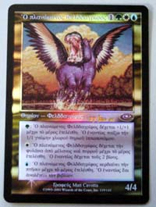
The new set has been finally unveiled. Players around the world had a chance to try out Planeshift cards at the Prerelease tournaments held over the weekend. Although Planeshift cards will not become legal for Constructed play for several more weeks, it gave players a chance to begin adjusting to the impact of this very different set on the sealed deck and draft environments.
The Prerelease card given out was a foil Questing Phelddagrif. Following the trend set with a Raging Kavu in Latin, this card is in Attic Greek. WotC insiders hint that those who found the dead languages theme interesting, will really enjoy the Apocalypse Prerelease card.
Phyrexian Scuta, Orim's Chant, and Shivan Wurm appear to be among the more sought-after rare cards at the moment. Other favorites will likely emerge after the set hits stores next Monday.

GRAND PRIX HIROSHIMA

Unlike the last several Grand Prix in Asia, none of the foreign pro players save myself have attended (and I pretty much scrubbed out). The total attendance was somewhat low for a Japanese tournament, at 450 players. The weather was partly to blame. Although Hiroshima escaped with only minor drizzle over the weekend, Tokyo and other parts of Japan were subjected to heavy snow.
Plenty of Japanese pros did show up, with many of the well-known players making the Top 8. The final match came down to a battle between the two-time APAC champion Masaya Mori against last year's national champion Masayaki Higashino. Higashino prevailed, adding another title win to his resume.
Another Top 8 finisher - Kotsuhiro Mori - was the talk of the tournament. This young player has made his third Grand Prix Top 8 finish in a row - and he has never yet played on the Pro Tour! Mori will be attending Pro Tour: Los Angeles. A decent finish there would put him in the lead of the Rookie of the Year race.

COMING UP: PRO TOUR LOS ANGELES
Players will be returning to everyone's favorite Pro Tour location this weekend, to compete in the Invasion Rochester Draft format. Plenty has already been written and posted in the way of PT LA previews. Much attention has been given to the newly revitalized Fantasy Pro Tour. Fantasy PT is an great way to get more involved with the coverage, so every one of you go and submit teams - after you finish reading this column, of course.
The Sideboard will be doing live coverage from LA. Full time reporters over the weekend will include Omeed Dariani, Michelle Bush, Josh Bennett, Anthony Alongi and Mason Peatross.

TRADING TRENDS
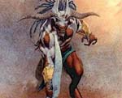
Planeshift includes an unexpected treat for collectors. Foil versions of the three Legendary cards in the set - Ertai, Tangharth, and Weatherlight - feature alternative artwork. Some players have speculated that only some foil cards feature this artwork, while others use the same art as the non-foil cards. This is inaccurate - all foils have the same art.

MAGIC TRIVIA
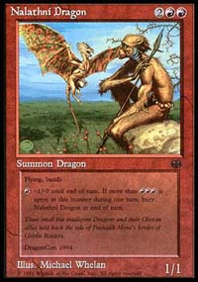
Last week, I asked what was the very first unique promotional card. The answer was Nalathni Dragon. This card was only given out to players attending the DragonCon gaming and science fiction convention in Atlanta. With only several hundred copies given out, collectors were going crazy, trying to get their hands on this card. It reached as high as $50+ on the Internet. The craze died down very quickly - after a copy of Nalathni Dragon was included for free with the next issue of The Duelist magazine.
To make up for such an easy question, there are two questions for you this week. Both are from the trivia game show hosted at GP Hiroshima by R&D member Mons Johnson (of Mons Goblin Raiders fame) and Japan/APAC play manager Ron Foster.
Mons has a soft spot for Goblins - so he came out with this little puzzle. There are two specific Goblins in play. One of them may ONLY attack if the other one attacks. What are the two Goblins?
The second question came from one of the players, and was sufficient to stump the hosts. Think you can do better?
There is a way to take mana burn twice in the same phase. How can this be done?
Please do not e-mail me with your answers. There is no prize, this is strictly for fun. Correct answer will be posted in the next week's column.

BEST OF THE NET

Now that the Planeshift card list is available to the online community, everyone with some spare time and a keyboard seems to be writing articles evaluating the new set. Perhaps the best Planeshift review I've read so far is by Zvi Mowshowitz. In this article, Zvi goes over his top Planeshift picks, and why he finds those cards particularly interesting. This article avoids most of the major pitfalls a new set reviewer might fall into - dwelling over obvious cards/card uses, inadequately explaining why certain cards are good and, most importantly, praising the bad cards due to the inexperience of the author.

PLAY OF THE WEEK
This week's play comes courtesy of Sol Malka, an internet columnist and an imaginative deckbuilder. Here is the play, in his own words:
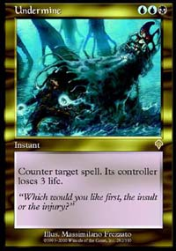
"I was participating in a local (Atlanta) Type 2 tournament, playing my Red/Black control deck. In the fifth round I met Jeremy Anderson, who was using a rogue Blue/Black control deck featuring Yawgmoth's Agenda, lots of blue deck manipulation, and Thrashing Wumpus and Blind Seer for the kill. Late in the second game I found myself at 3 life from a Thrashing Wumpus that I hadn't been able to kill right away. Each of us had plenty of mana in play, though neither of us had a victory condition on the board, and Jeremy's life was stable at around 13. Compounding the situation was the Yawgmoth's Agenda in play on his side and Undermine in his graveyard. In other words, the next time I cast a spell, Jeremy would Undermine it and kill me!
The only way I could cast a spell and not immediately lose would be if Jeremy had already played a spell on a given turn. He was giving me opportunities, as during each of my end steps he would play one of the various card-drawing cantrips (Accumulated Knowledges or Opts) in his graveyard. Unfortunately I couldn't find what I needed before he emptied his graveyard of those cards, leaving only Thwart, Misdirection, and of course the Undermine as relevant cards in his graveyard.
Finally I drew the one card I needed. Now I had to wait for an opportunity to play it. Sure enough, after a couple turns Jeremy attempted to Recoil his Yawgmoth's Agenda on my end step. In response I slammed my card: Boil! This removed every source of blue mana on Jeremy's team, and he couldn't do anything about it. He was forced to replay the Agenda to get back a few Islands he'd discarded in the early game, but I kept those locked down with Ports while playing a few creatures out of my hand. With those I served and won the game in a couple more turns."

BAD PLAY OF THE WEEK?
Bad plays are pretty easy to come by at the Prerelease. Here are two that really caught my attention:
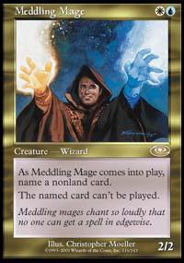
Pikula strikes again!
The first happened to my friend at the New York Prerelease. He cast Goblin Game (which was probably his first mistake), but to make things worse he did not read the card carefully. Thus, he revealed a box of 100 sleeves to his opponent. He did win the Goblin Game - but lost the actual game, taking 100 points of damage.
The other play comes from the pre-release at Essex, UK, courtesy of Luke Twigger. Here is what he wrote:
"My (deliberately anonymous) opponent went first, laying a Plains, I laid a Swamp and was done. He played an Island and then tapped both his lands to make a Meddling Mage, puzzlingly naming "Armadillo Cloak" as the spell that couldn't be played (I guess he must have been beaten up by one earlier). Anyway, I played another land and was done, so on his turn he plays a Forest and then taps all his land to enchant his Meddling Mage with [drum Roll] Armadillo Cloak! Then he called a judge when I pointed out he couldn't do that. So he spent the next few turns suicide-attacking with his Mage in an attempt to get me to kill it so he could use his Cloak :-)"
As always, please send good/bad plays and other news to ashv@concentric.net.

